Ongoing ubergaiter notes

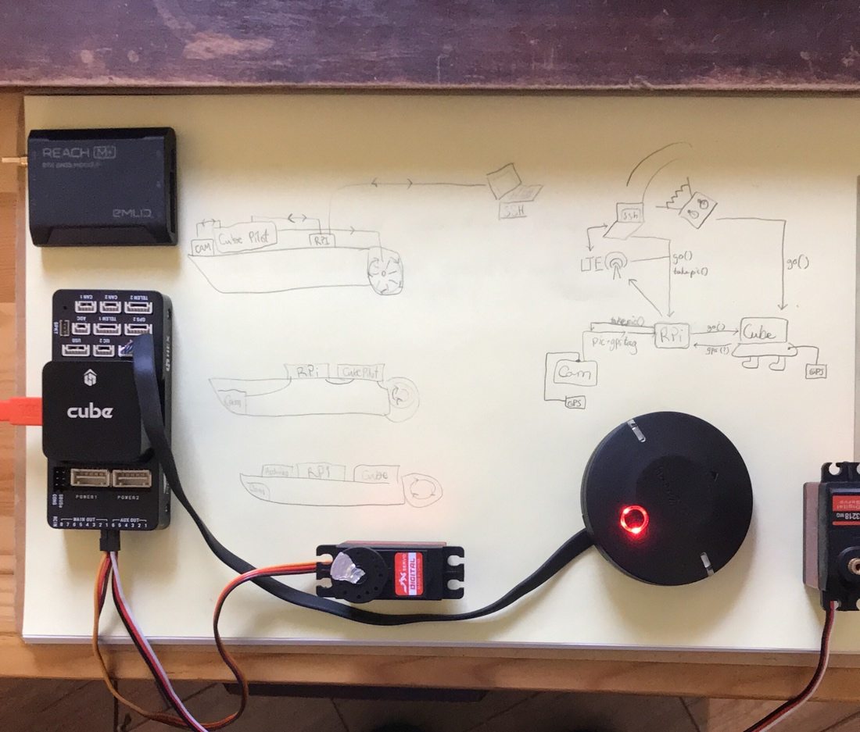

Antenna made of plexiglass, with gps and cameras and sonar

Get infrared picture of path to future survey area before starting and require human review before leaving and also at survey area

Aruco tags with open cv

<https://www.pyimagesearch.com/2020/12/21/detecting-aruco-markers-with-opencv-and-python/>

Maverick for transforming the rasp into a decent flight controller

Need a proximity sensor

A yacht depth sensor could be used

Compare gps location’s depth and sensed depth ( can sonar detect plants?)

A 360 camera mounted at top would be useful for intrusion/ proxim/ extraction

A collision sensor These are a bit less dire since runs at night

Water Current computing.

We will have to disable safety switch

BRD_SAFETYENABLE = 0 to disable the switch

Emlid IN rPi usb : <https://community.emlid.com/t/how-to-receive-reach-rtk-gps-data-on-raspberry-pi-3-via-usb/9055>

Or

Emlid in Camera :

<https://www.robotshop.com/ca/fr/adaptateur-hot-shoe-pour-reach-m-emlid.html>

**Todos:**

-Connect camera to pi (ghoto2 and opencv)

<https://sparkle-mdm.medium.com/use-a-digital-camera-in-opencv-instead-of-webcam-d8445898e6c8>

<https://docs.opencv.org/4.x/d5/dae/tutorial_aruco_detection.html>

-Connect raspberrypi to cubepilot, by wires

<https://discuss.cubepilot.org/t/how-connect-to-cube-orange-to-raspberrypi-4-model-b/6800/2>

-Connect RealVNC so we can ssh (operate and transfer files remotely)

<https://help.realvnc.com/hc/en-us/articles/360002249917-VNC-Connect-and-Raspberry-Pi#running-directly-rendered-apps-such-as-minecraft-remotely-0-5>

-Connect raspberry pi to lte wifi dongle and get ip address then create ssh

-Get graphic user interface over ssh (vnc), from users laptops

(done for mac) - open terminal. ssh -X [uberg@192.168.2.73](mailto:uberg@192.168.2.73)

- open realvnc. enter address: 192.168.2.73 (will change when lte)

- go to /home/uberg/Uberg/mission, open terminal : mono MissionPlanner.exe

5g connection on rasp : <https://www.google.com/search?q=why+cant+my+raspberry+pi+connect+to+5g+redout+lock&sxsrf=APq-WBtdIcjp04yEOvv511zlaxelYT38zA%3A1647393436259&ei=nDoxYrmZD5OrtQa_xpuwCQ&ved=0ahUKEwi518rkusn2AhWTVc0KHT_jBpYQ4dUDCA4&uact=5&oq=why+cant+my+raspberry+pi+connect+to+5g+redout+lock&gs_lcp=Cgdnd3Mtd2l6EAM6BwgjELADECc6BwgAEEcQsAM6BAghEBVKBAhBGABKBAhGGABQ_wNYoglg6wxoAXABeAGAAfUDiAG9C5IBCTItMS4xLjEuMZgBAKABAcgBCcABAQ&sclient=gws-wiz#kpvalbx=_rjoxYqaOLtertQayoLrYDg30>

- Create a gmail or outlook account (prob outlook for teams and all) proper to uberg so we can sign in realvnc and other things and all have logins

-Install OpenCv, GPhoto on raspberry pi

<https://www.aranacorp.com/en/installing-opencv-on-raspberry-pi/>

-Install GPS on pi

<https://maker.pro/raspberry-pi/tutorial/how-to-use-a-gps-receiver-with-raspberry-pi-4>

Or with here2-reach m+

-Control camera from mission planner to take pictures with gps location

<https://ardupilot.org/planner/docs/common-camera-control-and-auto-missions-in-mission-planner.html>

Then:...

-Get full connection of the system as it was with rockpine

- recreate on rPi

-Power servos

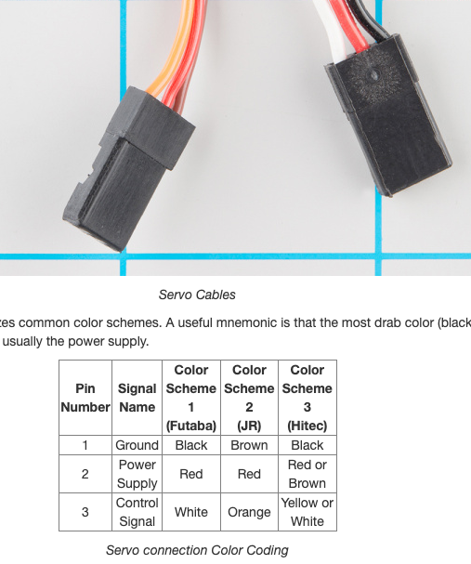

-Figure power supply strategy

<https://ardupilot.org/rover/docs/rover-motor-and-servo-configuration.html?highlight=rover%20servo%20connection>

-Plan mock mission

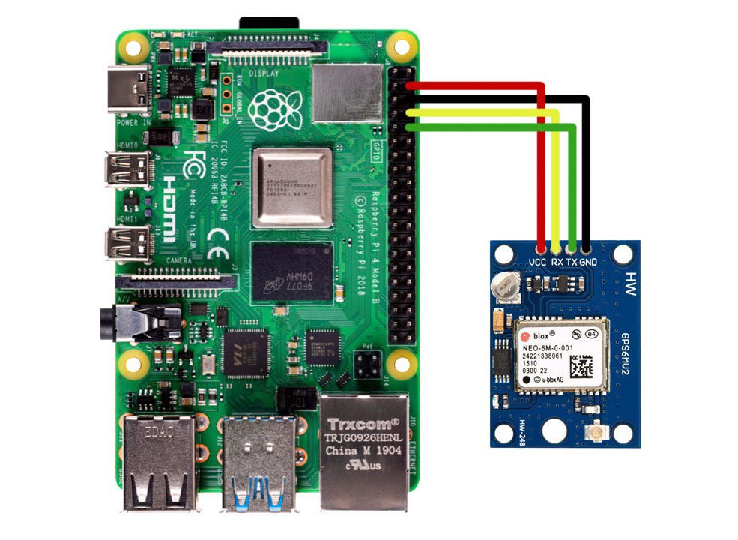-Connect to actual boat and motors

<https://discuss.cubepilot.org/t/indoor-autonomous-flight-with-cube-ros-and-aruco-board-ongoing/351/2>

-Connect an identification to a coordinate in a geodb.

**RC**

**Leftmost = (-) (yellow), middle = (+)(orange), rightmost = (serial)(red). Plug in I-bus –servo in fs-ia10b and in rc in on cubepilot**

### **Channel mappings**

Rover default channel mappings are:

* **Channel 1**: Steering or rc3
* **Channel 3**: Throttle or rc1
* **Channel 8** (default): Flight modes. Mode selection can be mapped to any RC channel using the [MODE_CH](https://ardupilot.org/rover/docs/parameters.html#mode-ch) parameter
* **Channel 7 to 12**: (Optional) Auxiliary function switches

**Docs**

Cubepilot

<https://docs.cubepilot.org/user-guides/autopilot/the-cube-user-manual>

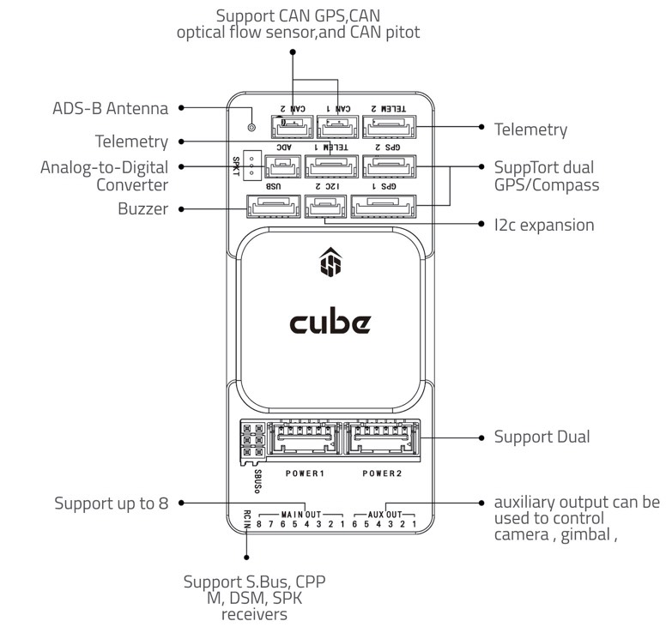

Tentative Color code for Telem1

Red 5v

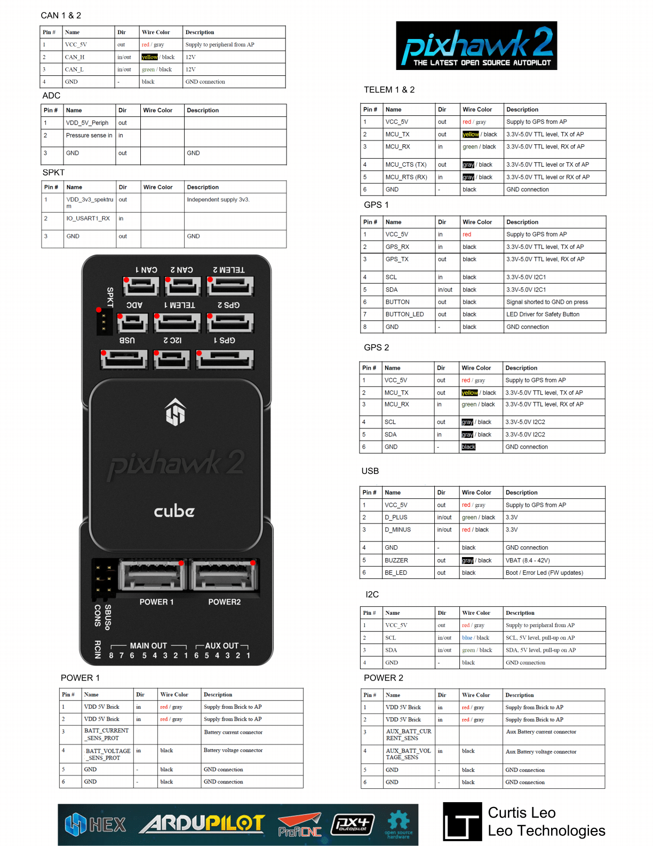

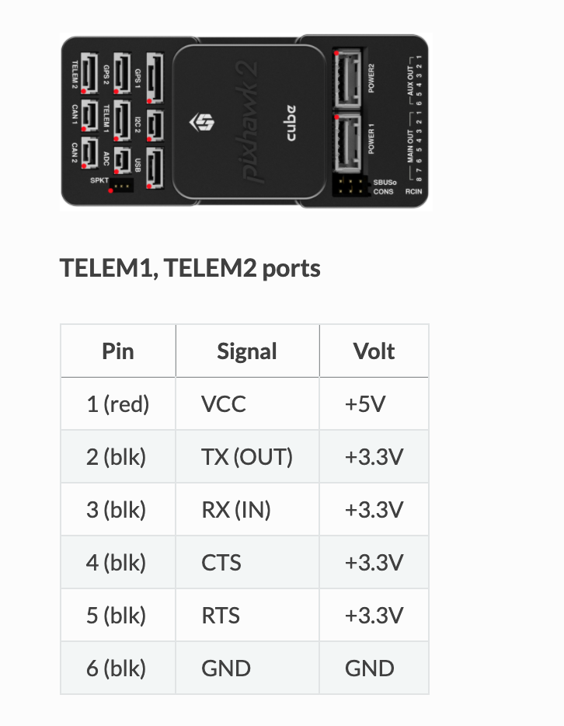

That’s the normal wire

Red is to the right if telem1 is read normally (not upside down) and so red is on the right

With our telem – breakout(rPi) wire

1 = black(vcc 5+v)

2 = yellow (TX-out)

3 = green (RX-in)

4 = blue(CTS)

5 = white(RTS)

6 = red (GND)

So red = black and black = red (BEWARE)

So : GPIO 14 = yellow (tx) GPIO 15 = green (rx). GND = red (gnd)

So

Raspberry Pi

GOOD SOURCE : <https://docs.px4.io/master/en/companion_computer/pixhawk_companion.html>

<https://discuss.cubepilot.org/t/indoor-autonomous-flight-with-cube-ros-and-aruco-board-ongoing/351>

<https://www.etechnophiles.com/raspberry-pi-4-gpio-pinout-specifications-and-schematic/>

<https://docs.px4.io/v1.9.0/en/assembly/quick_start_cube.html#telemetry>

<https://ardupilot.org/plane/docs/common-telemetry-landingpage.html#common-telemetry-landingpage>

<https://www.linkedin.com/pulse/communication-between-drone-raspberry-pi-via-mavlink-yan-pang>

<https://stackoverflow.com/questions/64981118/connect-mavlink-on-rpi-with-qgroundcontrol>

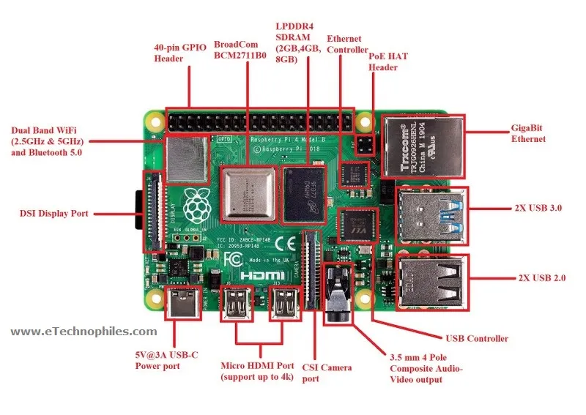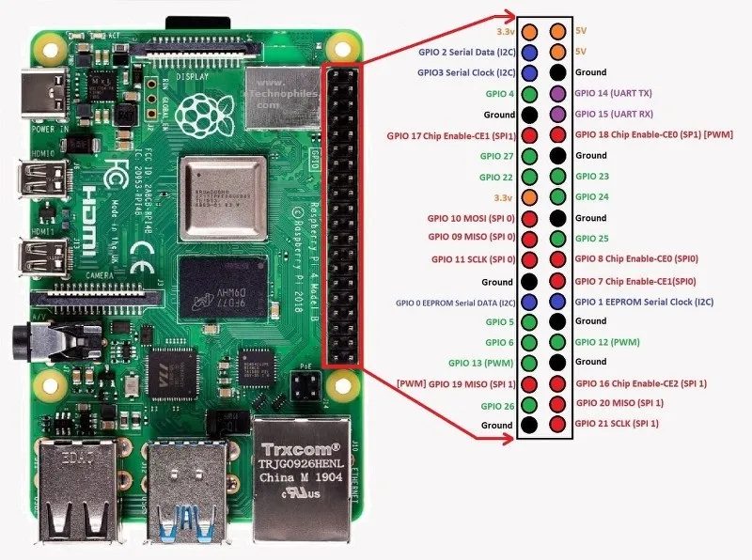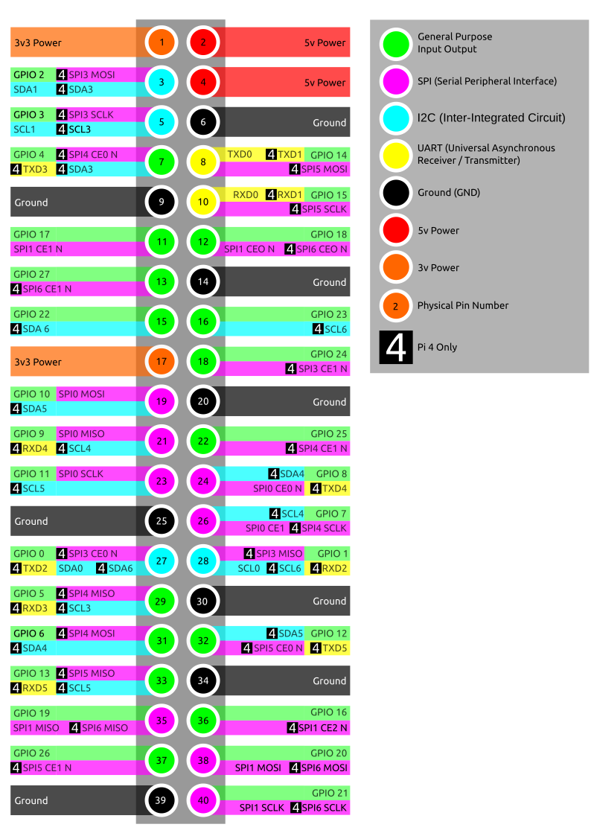

<https://docs.px4.io/master/en/assembly/quick_start_cube.html>

Emlid docs <https://emlid.com/support/reach-m/>

**Gear**

PX4 - bus anæd sensors (accelerometer

Cubepilot - controller

Here2 – gps1

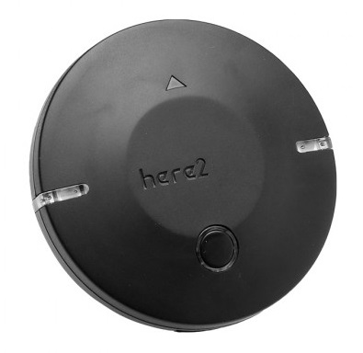

Reach M+ from Emlid – gps2

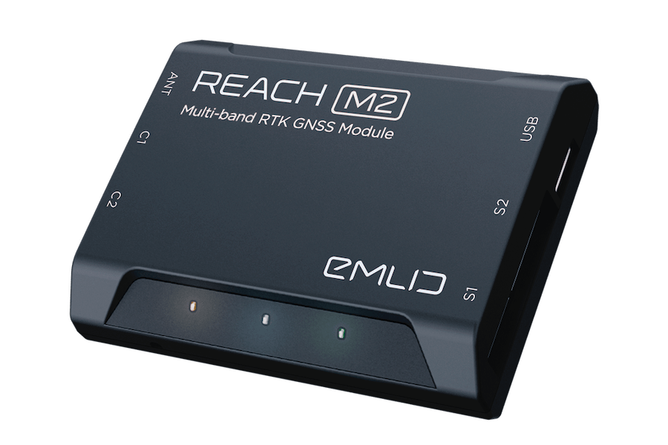

2x servo (PDI-6221MG-180)

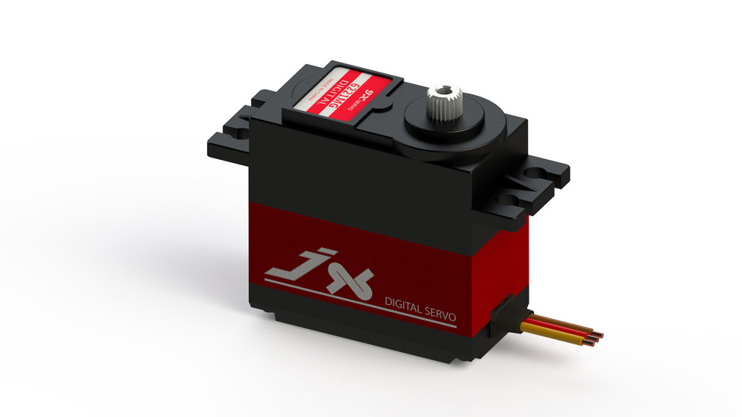

Wifi telemetry antenna

Rebel 2 Canon Camera

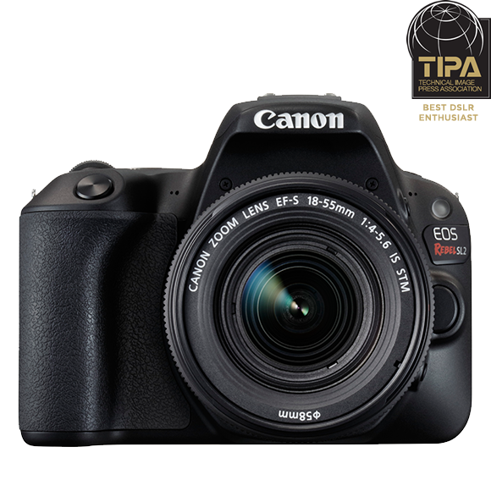

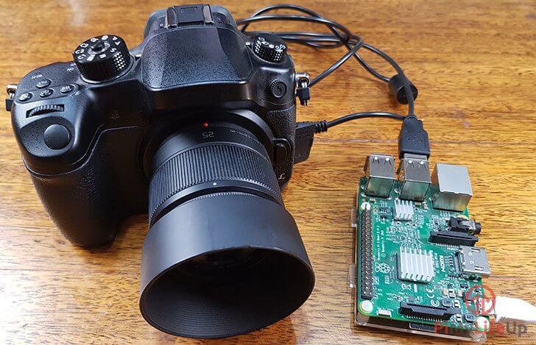

*the bus holds all the plugs for connections

**Connections**

Power1 - power module - battery

XT60 droite - batterie / ?

XT60 gauche - ?

GPS1 - Here2

GPS2 - ? (EMLID REACH M+) (make fil) ou estce par

I2c - can bus splitter - buzzer

Main out 1 - servo 1

Main out 2 - servo 2

Reach M+ has an app: Reach view 3, for ios or android

1. Connect the reach
2. Connect to wifi
   1. reach:B6:3D.
   2. password: emlidreach

**Instructions**

Installing Mission Planner and QGroundControl on Rasp

Mission planner: **note : mono works only on legacy raspbian buster, not bullseye yet

<https://www.mono-project.com/download/stable/#download-lin-raspbian>

<https://ardupilot.org/planner/docs/mission-planner-installation.html>

Go to /home/uberg/MissionPlanner

Open terminal window in that folder

Execute mono MissionPlanner**.**exe

QGroundControl *supposed to be more stable

Apm planner deprecated

To Run Mission planner : home/uberg/Uberg/mission/ open terminal : mono MissionPlanner**.**exe

**Guides**

Controlling pixhawk with rasp: <https://discuss.cubepilot.org/t/how-connect-to-cube-orange-to-raspberrypi-4-model-b/6800/2>

**Needs**

(telemetry) Wifi transmitter

Other XT60 connector

SBUS driver

**Material needed**  
Raspberry pi wires

6-pin df13 connector to 6 female dupont connectors ( connect into telem2 )

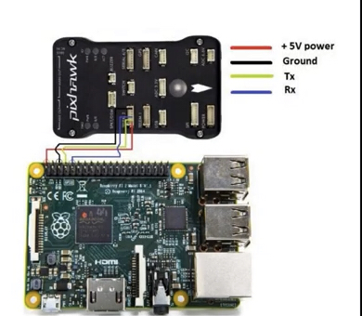

**Questions**

GPS2 Cable (all ends go somewhere else, goes where)

Reach M+ semble ne pas connecter

What does the TOBSUN power?

How to activate safety switch

**Auxiliary output can be used to control camera

**Existing Code**

capture.py (uses opencv!)

Take a picture, set timestamp, rename file with timestamp

*Sugg: could it also run gps and add that to metadata as well as timestamp?

Look at gphoto2

gpslocation.py

Get gps data and time (GGA, RMC, AOG), sets a socket and sends data to UDP_IP, UDP_PORT

#IP and Port for the computer runnign AgOpenGPS

UDP_IP = '192.168.11.27'

NMEAO183.py

Get GPS data

Not sure what it does with it

untitled.py

Write data from socket into a csv (gpsdata.csv)

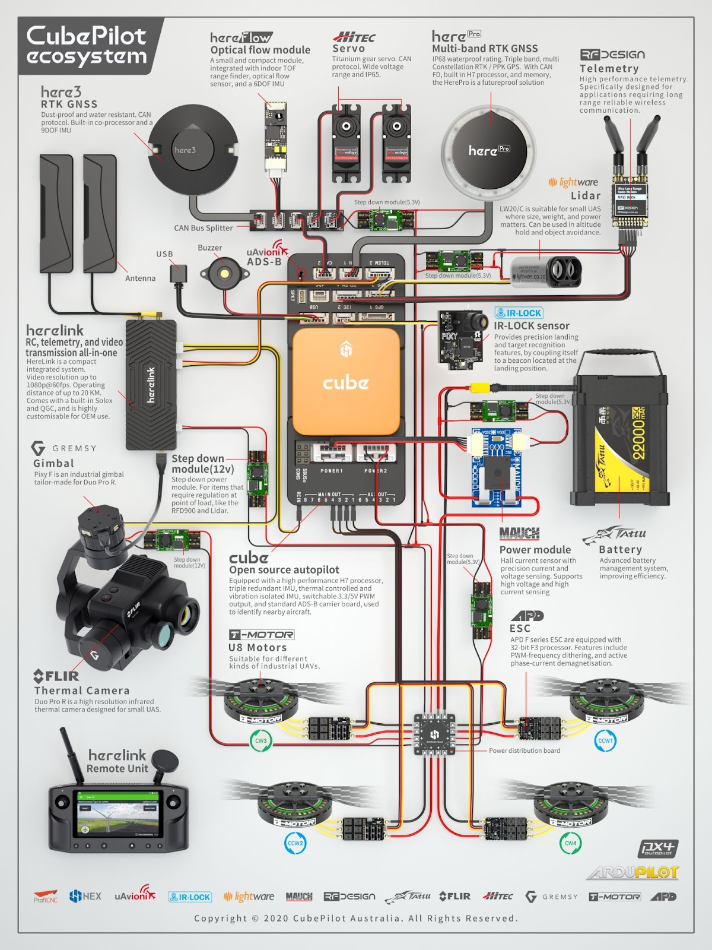

gpiozero docs

<https://gpiozero.readthedocs.io/en/stable/recipes.html>

**RADIO CALIBRATION AND REMOTE**

[**https://files.banggood.com/2016/09/FS-i6X%20User%20manual.pdf**](https://files.banggood.com/2016/09/FS-i6X%20User%20manual.pdf)

[**https://www.horizonhobby.com/on/demandware.static/Sites-horizon-us-Site/Sites-horizon-master/default/Manuals/FSY004-Manual.pdf**](https://www.horizonhobby.com/on/demandware.static/Sites-horizon-us-Site/Sites-horizon-master/default/Manuals/FSY004-Manual.pdf)

**Ideas**

Locate plants then

Go back other nights to get higher resolution acquisition

Data output from a gateway on the shore of the lake (power consumption)

Qi charging at electromagnetic pier

Ideally : Identify geo assets over lorawan (very small packets)

Accumulate pictures at night. (Do analysis and reshoots on the spot) Slow and tedious capture.

Do picture categorization during the day, with solar panel and no motors on. (perhaps at connected pier) Send data to geodb in server; Update geoxml feature file. Interface uses db so is up to date.

This strategy would mean that the mission planner has full use of the rasp pi during mission, at first.

***POWER***

Mophie powerstation

NOCO : Charger

<https://no.co/products/charging/genius>

NOCO has adaptors

<https://no.co/media/nocodownloads/format/x/-/x-connect-accessories_4.pdf>

So maybe an arm that shoots to a funneled plug, the arm would just connect, then would release the wire so the boat can sway...

Maybe modifying the plugs to add a wider connection and magnets

Info from the charger would be useful to avoid overheating

NEED A SHELTER FOR THIS SYSTEM

PMA is a powerful wireless charging technology that could perhaps work. But maybe not powerful enough

**Later:**

Mission_night

resume_to_turf()

While (time, conditions, power, allowed, turf)

monitor()

capture()

analysis_threshold()

capture() or next position()

back_to_dock()

mapping_day

While (time, power, content)

monitor()

clean_data()

geoxml += categorize()

send_to_db()

set_mission(turf, analysis_thres)

charge()

To be able to take pictures and navigate arbitrarily, rPi needs to send terminal commands to mission planner.

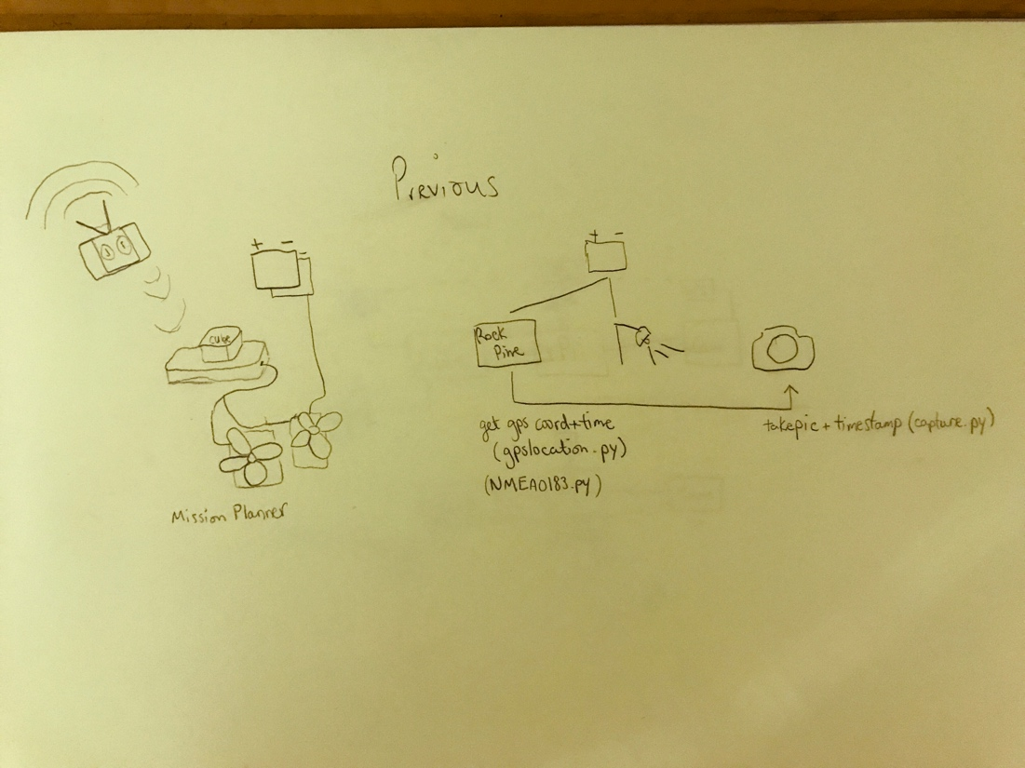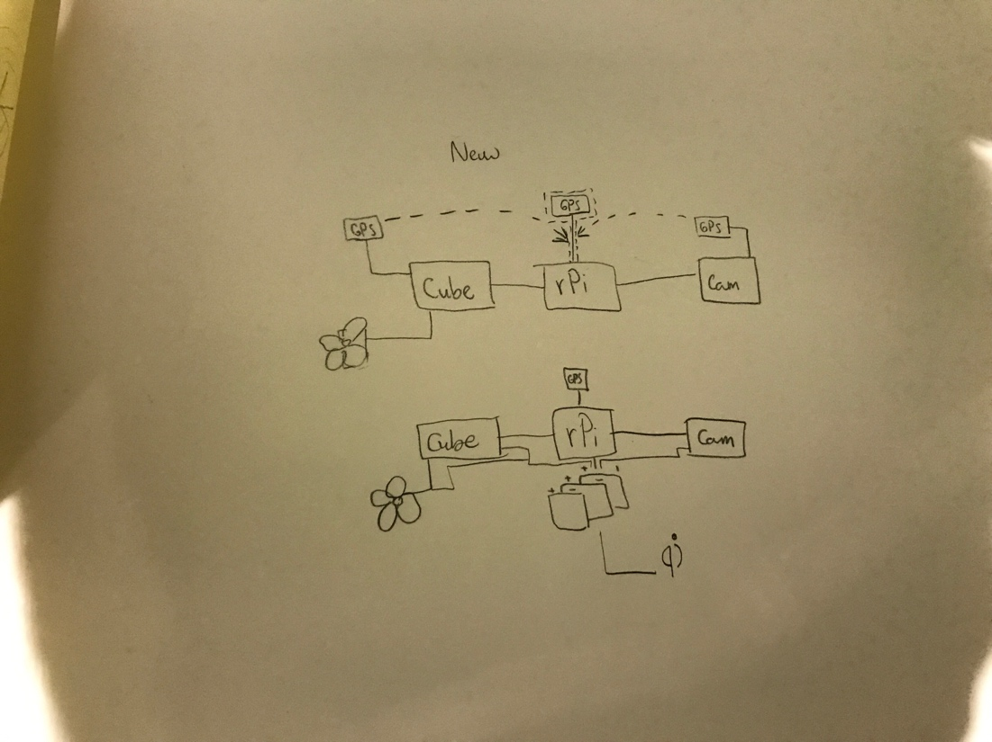

Relay

<https://www.circuitbasics.com/wp-content/uploads/2015/11/SRD-05VDC-SL-C-Datasheet.pdf>

Camera

Rebel sl2 eos 200d

RealVNC to ssh over the internet!

<https://help.realvnc.com/hc/en-us/articles/360002249917-VNC-Connect-and-Raspberry-Pi#operating-vnc-server-at-the-command-line-0-10>

ROCK PINE 64

A64

<http://files.pine64.org/doc/Pine%20A64%20Schematic/Pine%20A64%20Pin%20Assignment%20160119.pdf>

Old Pixhawk

<https://ardupilot.org/copter/docs/common-servo.html>

GP2 - geotagging library

Great channel : <https://www.youtube.com/watch?v=LyPtzv0y5DE> explains rc, navigators, the cube, all

Wifi mlid reach configure autopilote NMEO

Great channel for using drone scripting, ROS and opencv with raspberry pi and pixhawk

<https://youtu.be/cZVNndOaYCE>

Wireless charging

<https://youtu.be/N_L3MuPEHa8>

Navigating strategies

If stuck reverse

Return to home is done from reversing to start of survey and retracing path ( not straight line)

Steps

Plan missions on mission planner and use DO commands to take pictures at specific gps location

Mission planner first, then man proxy

One process is mission planner

A parallel process listens for new pictures and then analyses them giving coordinate and plant(s) type

Another process sends the missions data

Then if that works, use mavproxy to change the mission with the analysis in real time (not needed now at first)

See:

UgCS supports multiple map layers as well as different map providers. Some of the features of UgCS include - DEM Import, ADS-B transponder and receiver support, Click & Go mode, Joystick mode, image geotagging and video recording. UgCS also comes with a telemetry player, allowing the replay of all flights.